**Movie Ticket Booking Website**

(Only Frontend)

Subject-CSE326

Submitted By-

1. Ritesh Kumar Swain 12306819
2. Saksham 12305209
3. Bunty Kumar Sharma 12303979
4. Aryan 12306485

**Introduction**

The backbone of our web infrastructure was built using HTML (Hypertext Markup Language) to define the structure and content of the pages. CSS (Cascading Style Sheets) was utilized to enhance the visual presentation.

Welcome to our awesome Movie Ticket Booking website! It's super easy to use and helps you book movie tickets quickly. Our website is designed to be simple and cool. When you visit, you'll see all the latest movies right down the homepage or you can click on the movie section then you can directly see the latest movies.

On our website, we've made it super simple for you to find the movies you love. Check out our awesome filter section you can easily sort movies by genre! Whether you're in the mood for a good laugh with comedy, a spine-tingling experience with horror, the adrenaline rush of action, or the magic of animation, we've got you covered. Explore and discover your favorite films with our easy-to-use genre filters!

Upon entering the website, users are greeted with a visually stunning homepage. Then there is the filter section. On the left side of the filter section there is an upcoming movie poster. You can also play the trailer of the upcoming movie by clicking the play trailer button. Under the upcoming movie poster you will get suggestions of different movies with their price tags and name of that movie.

A homepage that looks awesome and shows you the coolest movies. You can easily click around to check out different movies.

Everything looks nice and colorful thanks to our use of styles, making it all easy on the eyes

In the absence of backend complexity, the focus remains on delivering a front-end that captivates users and simplifies their movie ticket booking experience.

So, go ahead, explore, and have fun booking your movie tickets! We're here to make your movie experience easy and enjoyable. Lights, camera, action – let the entertainment begin!

**Technology Used**

In this online ticket booking website, HTML and CSS play fundamental roles in shaping the user interface and overall structure of websites. HTML (Hyper Text Markup Language) is utilized for creating the structural framework, defining essential elements such as buttons for navigation, and placeholders for search bar and buttons. This included defining essential elements such as navigation bar, search bars, buttons, paragraphs and links, crucial for presenting information and enabling user interaction.

CSS (Cascading Style Sheets) complements HTML by providing the means to apply visually appealing styles and layouts to these elements. The customization of fonts, colors, and layouts to create a seamless and engaging experience for users navigating the online ticket booking platform.

To develop our website, we opted for Visual Studio Code (VS Code) as our primary software tool. VS Code, a lightweight yet powerful source code editor, provided an efficient environment for creating and editing HTML and CSS files.

Overall, Visual Studio Code proved to be a vital asset, enhancing our productivity and contributing to the successful creation of a website.

By applying HTML and CSS, we achieved user-friendly ticketing website and interactive design.

**Module**

1. **home.html**
2. **<!DOCTYPE html>**
3. **<html lang="en">**
4. **<head>**
5. **<meta charset="UTF-8">**
6. **<meta name="viewport" content="width=device-width, initial-scale=1.0">**
7. **<title>Movie Ticket</title>**
8. **<style>**
9. **\*{**
10. **scroll-behavior: smooth;**
11. **}**
12. **body{**
13. **background-color:#1e1f26;**
15. **}**
16. **.navbar{**
17. **overflow: auto;**
18. **width: 207%;**
19. **background:rgba(255, 255, 255, 0.589);**
20. **backdrop-filter: blur(5px);**
22. **}**
23. **.navbar:hover{**
24. **background-color: rgb(75, 73, 73);**
25. **font-weight: bolder;**
26. **transition: all ease 1s;**
27. **}**
28. **.nv{**
29. **position: absolute;**
30. **top: 0%;**
31. **left: 0%;**
32. **display: block;**
33. **text-decoration: none;**
34. **}**
35. **.navbar li{**
36. **float: left;**
37. **list-style: none;**
38. **margin: 13px 30px;**
39. **font-family: cursive;**
41. **}**
42. **.navbar li a{**
43. **padding: 19px;**
44. **text-decoration: none;**
45. **color:black;**
47. **}**
48. **.navbar li a:hover{**
49. **color: rgb(41, 187, 41);**
50. **}**
51. **.search{**
52. **color: white;**
53. **padding:10px 75px;**
54. **margin: 4px;**
55. **}**
56. **.navbar input{**
57. **border: 2px solid black;**
58. **border-radius: 7px;**
59. **padding: 3px 17px;**
60. **width: 120px;**
61. **}**
62. **.logo{**
63. **font-size: 20px;**
64. **color: rgb(0, 0, 0);**
65. **float: inline-start;**
66. **font-family:cursive;**
67. **}**
68. **.logo:hover{color: rgb(221, 65, 91);}**
69. **.im1{**
70. **width:101%;**
71. **height: 585px;**
72. **}**
73. **.para span{**
74. **color: green;**
75. **}**
76. **.para::after{**
77. **content: "";**
78. **position: absolute;**
79. **left: 0;**
80. **bottom: 0;**
81. **height: 8px;**
82. **width: 10%;**
83. **background-color: white;**
84. **transition: all ease 1s;**
85. **}**
86. **.para:hover::after{**
87. **width: 95%;**
88. **}**
89. **.para{**
90. **position: absolute;**
91. **top: 54%;**
92. **left: 66%;**
93. **color: white;**
94. **display: block;**
95. **text-decoration: none;**
96. **font-weight: bold;**
97. **font-size: 45px;**
98. **font-family:monospace;**
99. **}**
100. **section{**
101. **padding: 20px;**
103. **}**
104. **.apply{**
105. **border: none;**
106. **padding: 10px;**
107. **border-radius: 10px;**
108. **margin: 4px 2px;**
109. **cursor: pointer;**
110. **background: #ffa500;**
111. **font-weight: bold;**
112. **text-align: center;**
113. **}**
114. **.apply:hover{**
115. **color: green;**
116. **}**
117. **.container{**
118. **color: white;**
119. **display: grid;**
120. **grid-template-columns: 1fr 3fr;**
121. **gap: 2rem;**
123. **}**
124. **.sidebar{**
125. **background: #646363a9;**
126. **backdrop-filter: blur(5px);**
127. **height: fit-content;**
128. **border-radius: 1rem;**
129. **padding: 2rem 2.5rem;**
130. **width: 18%;**
131. **float: inline-start;**
132. **}**
133. **.sidebargrp{**
134. **margin-bottom: 1rem;**
135. **}**
136. **.title{**
137. **margin-bottom: .5rem;**
138. **color: whitesmoke;**
139. **font-weight: bold;**
140. **}**
141. **input{**
142. **margin-bottom: .6rem;**
143. **}**
144. **input[type=checkbox]:checked{**
145. **accent-color: orange;**
146. **}**
147. **input[type=radio]:checked{**
148. **accent-color: orange;**
149. **}**
150. **label{**
151. **margin-left: .5rem;**
152. **}**
153. **.umovie{**
154. **float: inline-end;**
155. **position: relative;**
156. **width: 70%;**
157. **height: 614px;**
158. **border-radius: 2rem;**
159. **overflow: hidden;**
160. **}**
161. **.um1{**
162. **width: 100%;**
163. **}**
164. **.cl1{**
165. **position: absolute;**
166. **top: 2rem;**
167. **left: 2rem;**
168. **color:#ffa500;**
169. **background-color: #1e1f26;**
170. **padding: .5rem 1rem;**
171. **border-radius: 2rem;**
172. **border: 1px solid #ffa500;**
173. **font-weight: 500;**
174. **}**
175. **.button{**
176. **position: absolute;**
177. **bottom: 2rem;**
178. **left: 2rem;**
179. **}**
180. **.cl2{**
181. **background-color: #1e1f26;**
182. **color: #ffa500;**
183. **border: 1px solid #ffa500;**
184. **margin-left: 1rem;**
185. **padding: .5rem 1rem;**
186. **border-radius: 2rem;**
187. **text-decoration: none;**
188. **}**
189. **.cl2:hover{**
190. **background-color: #92601f;**
191. **}**
192. **@keyframes scaleUp {**
193. **0% {**
194. **transform: scale(1);**
195. **}**
196. **50% {**
197. **transform: scale(1.1); /* Adjust the value for the "hover" effect */**
198. **}**
199. **100% {**
200. **transform: scale(1);**
201. **}**
202. **}**
203. **@keyframes scaleDown {**
204. **0% {**
205. **transform: scale(1);**
206. **}**
207. **50% {**
208. **transform: scale(0.9); /* Adjust the value for the "active" effect */**
209. **}**
210. **100% {**
211. **transform: scale(1);**
212. **}**
213. **}**
214. **.m1{**
215. **border: 1px transparent;**
216. **height: 300px;**
217. **width: 350px;**
218. **display: inline-block;**
219. **border-radius: 1rem;**
220. **float: left;**
221. **margin: 30px;**
222. **transition: transform 0.3s ease;**
223. **}**
224. **.m1:hover{animation: scaleUp 0.2s ease;}**
225. **.m1:active{ animation: scaleDown 0.2s ease;}**
226. **.name{**
227. **position: absolute;**
228. **left: 75px;**
229. **top: 1346px;**
230. **color: gold;**
231. **}**
232. **.p1{**
233. **position: absolute;**
234. **left: 75px;**
235. **top:1571px;**
236. **border: 1px solid #ffa500 ;**
237. **background-color: #1e1f26;**
238. **color: #ffa500;**
239. **text-decoration: none;**
240. **border-radius: .2rem;**
241. **}**
242. **.p1:hover{**
243. **background-color: #92601f;**
244. **animation: scaleUp 0.2s ease;**
245. **}**
246. **.m2{**
247. **border: 1px transparent;**
248. **height: 300px;**
249. **width: 350px;**
250. **display: inline-block;**
251. **border-radius: 1rem;**
252. **float: left;**
253. **margin: 30px;**
254. **}**
255. **.m2:hover{animation: scaleUp 0.2s ease;}**
256. **.m2:active{ animation: scaleDown 0.2s ease;}**
257. **.name1{**
258. **position: absolute;**
259. **left: 500px;**
260. **top: 1346px;**
261. **color: gold;**
262. **}**
263. **.p2{**
264. **position: absolute;**
265. **left: 500px;**
266. **top:1571px;**
267. **border: 1px solid #ffa500 ;**
268. **background-color: #1e1f26;**
269. **color: #ffa500;**
270. **text-decoration: none;**
271. **border-radius: .2rem;**
272. **}**
273. **.p2:hover{**
274. **background-color: #92601f;**
275. **animation: scaleUp 0.2s ease;**
276. **}**
277. **.m3{**
278. **border: 1px transparent;**
279. **height: 300px;**
280. **width: 350px;**
281. **display: inline-block;**
282. **border-radius: 1rem;**
283. **float: left;**
284. **margin: 30px;**
285. **}**
286. **.m3:hover{animation: scaleUp 0.2s ease;}**
287. **.m3:active{ animation: scaleDown 0.2s ease;}**
288. **.name2{**
289. **position: absolute;**
290. **left: 900px;**
291. **top: 1346px;**
292. **color: gold;**
293. **}**
294. **.p3{**
295. **position: absolute;**
296. **left: 900px;**
297. **top:1571px;**
298. **border: 1px solid #ffa500 ;**
299. **background-color: #1e1f26;**
300. **color: #ffa500;**
301. **text-decoration: none;**
302. **border-radius: .2rem;**
303. **}**
304. **.p3:hover{**
305. **background-color: #92601f;**
306. **animation: scaleUp 0.2s ease;**
307. **}**
308. **.m4{**
309. **border: 1px transparent;**
310. **height: 300px;**
311. **width: 350px;**
312. **display: inline-block;**
313. **border-radius: 1rem;**
314. **float: left;**
315. **margin: 30px;**
316. **}**
317. **.m4:hover{animation: scaleUp 0.2s ease;}**
318. **.m4:active{ animation: scaleDown 0.2s ease;}**
319. **.name3{**
320. **position: absolute;**
321. **left: 75px;**
322. **top: 1693px;**
323. **color: gold;**
324. **}**
325. **.p4{**
326. **position: absolute;**
327. **left: 75px;**
328. **top:1925px;**
329. **border: 1px solid #ffa500 ;**
330. **background-color: #1e1f26;**
331. **color: #ffa500;**
332. **text-decoration: none;**
333. **border-radius: .2rem;**
334. **}**
335. **.p4:hover{**
336. **background-color: #92601f;**
337. **animation: scaleUp 0.2s ease;**
338. **}**
339. **.m5{**
340. **border: 1px transparent;**
341. **height: 300px;**
342. **width: 350px;**
343. **display: inline-block;**
344. **border-radius: 1rem;**
345. **float: left;**
346. **margin: 30px;**
347. **}**
348. **.m5:hover{animation: scaleUp 0.2s ease;}**
349. **.m5:active{ animation: scaleDown 0.2s ease;}**
350. **.name4{**
351. **position: absolute;**
352. **left: 500px;**
353. **top: 1693px;**
354. **color: gold;**
355. **}**
356. **.p5{**
357. **position: absolute;**
358. **left: 500px;**
359. **top:1925px;**
360. **border: 1px solid #ffa500 ;**
361. **background-color: #1e1f26;**
362. **color: #ffa500;**
363. **text-decoration: none;**
364. **border-radius: .2rem;**
365. **}**
366. **.p5:hover{**
367. **background-color: #92601f;**
368. **animation: scaleUp 0.2s ease;**
369. **}**
370. **.m6{**
371. **border: 1px transparent;**
372. **height: 300px;**
373. **width: 350px;**
374. **display: inline-block;**
375. **border-radius: 1rem;**
376. **float: left;**
377. **margin: 30px;**
378. **}**
379. **.m6:hover{animation: scaleUp 0.2s ease;}**
380. **.m6:active{ animation: scaleDown 0.2s ease;}**
381. **.name5{**
382. **position: absolute;**
383. **left: 900px;**
384. **top: 1693px;**
385. **color: gold;**
386. **}**
387. **.p6{**
388. **position: absolute;**
389. **left: 900px;**
390. **top:1925px;**
391. **border: 1px solid #ffa500 ;**
392. **background-color: #1e1f26;**
393. **color: #ffa500;**
394. **text-decoration: none;**
395. **border-radius: .2rem;**
396. **}**
397. **.p6:hover{**
398. **background-color: #92601f;**
399. **animation: scaleUp 0.2s ease;**
400. **}**
401. **.m7{**
402. **border: 1px transparent;**
403. **height: 300px;**
404. **width: 350px;**
405. **display: inline-block;**
406. **border-radius: 1rem;**
407. **float: left;**
408. **margin: 30px;**
409. **}**
410. **.m7:hover{animation: scaleUp 0.2s ease;}**
411. **.m7:active{ animation: scaleDown 0.2s ease;}**
412. **.name6{**
413. **position: absolute;**
414. **left: 75px;**
415. **top: 2050px;**
416. **color: gold;**
417. **}**
418. **.p7{**
419. **position: absolute;**
420. **left: 75px;**
421. **top:2285px;**
422. **border: 1px solid #ffa500 ;**
423. **background-color: #1e1f26;**
424. **color: #ffa500;**
425. **text-decoration: none;**
426. **border-radius: .2rem;**
427. **}**
428. **.p7:hover{**
429. **background-color: #92601f;**
430. **animation: scaleUp 0.2s ease;**
431. **}**
432. **.m8{**
433. **border: 1px transparent;**
434. **height: 300px;**
435. **width: 350px;**
436. **display: inline-block;**
437. **border-radius: 1rem;**
438. **float: left;**
439. **margin: 30px;**
440. **}**
441. **.m8:hover{animation: scaleUp 0.2s ease;}**
442. **.m8:active{ animation: scaleDown 0.2s ease;}**
443. **.name7{**
444. **position: absolute;**
445. **left: 500px;**
446. **top: 2050px;**
447. **color: gold;**
448. **}**
449. **.p8{**
450. **position: absolute;**
451. **left: 500px;**
452. **top:2285px;**
453. **border: 1px solid #ffa500 ;**
454. **background-color: #1e1f26;**
455. **color: #ffa500;**
456. **text-decoration: none;**
457. **border-radius: .2rem;**
458. **}**
459. **.p8:hover{**
460. **background-color: #92601f;**
461. **animation: scaleUp 0.2s ease;**
462. **}**
463. **.m9{**
464. **border: 1px transparent;**
465. **height: 300px;**
466. **width: 350px;**
467. **display: inline-block;**
468. **border-radius: 1rem;**
469. **float: left;**
470. **margin: 30px;**
471. **}**
472. **.m9:hover{animation: scaleUp 0.2s ease;}**
473. **.m9:active{ animation: scaleDown 0.2s ease;}**
474. **.name8{**
475. **position: absolute;**
476. **left: 900px;**
477. **top: 2050px;**
478. **color: gold;**
479. **}**
480. **.p9{**
481. **position: absolute;**
482. **left: 900px;**
483. **top:2285px;**
484. **border: 1px solid #ffa500 ;**
485. **background-color: #1e1f26;**
486. **color: #ffa500;**
487. **text-decoration: none;**
488. **border-radius: .2rem;**
489. **}**
490. **.p9:hover{**
491. **background-color: #92601f;**
492. **animation: scaleUp 0.2s ease;**
493. **}**
494. **.p9:active{ animation: scaleDown 0.2s ease;}**
495. **</style>**
496. **</head>**
497. **<body>**
498. **<div>**
499. **<img src="m1.avif" class="im1">**
500. **<header class="nv">**
501. **<nav class="navbar">**
502. **<li class="logo">Daily Cinema<br>Club</li>**
503. **<ul>**
504. **<li><a href="home.html">Home</a></li>**
505. **<li><a href="#sec1">Movies</a></li>**
506. **<li><a href="aboutm.html">About</a></li>**
507. **<li><a href="contactm.html">Contact Us</a></li>**
508. **<div class="search">**
509. **<input type="text" name="Search" placeholder="Search">**
510. **</div>**
511. **</ul>**
512. **</nav>**
513. **</header>**
514. **<p class="para">BOOK YOUR TICKETS FOR <span>MOVIES</span></p>**
515. **</div>**
516. **<section id="sec1">**
517. **<divclass="container">**
518. **<div class="sidebar">**
519. **<form action="#">**
520. **<div class="sidebargrp">**
521. **<h3 class="title">Categories</h3>**
522. **<input type="checkbox" id="adventure" name="adventure" value="adventure">**
523. **<label for="adventure">Adventure</label><br>**
524. **<input type="checkbox" id="action" name="Action" value="Action">**
525. **<label for="Action">Action</label><br>**
526. **<input type="checkbox" id="Animation" name="Animation" value="Animation">**
527. **<label for="Animation">Animation</label><br>**
528. **<input type="checkbox" id="Comedy" name="Comedy" value="Comedy">**
529. **<label for="Comedy">Comedy</label><br>**
530. **<input type="checkbox" id="Science Fiction" name="Science Fiction" value="Science Fiction">**
531. **<label for="Science Fiction">Science Fiction</label><br>**
532. **<input type="checkbox" id="Thriller" name="Thriller" value="Thriller">**
533. **<label for="Thriller">Thriller</label><br>**
534. **<input type="checkbox" id="History" name="History" value="History">**
535. **<label for="History">History</label><br>**
536. **<input type="checkbox" id="Documentary" name="Documentary" value="Documentary">**
537. **<label for="Documentary">Documentary</label><br>**
538. **<input type="checkbox" id="Fantasy" name="Fantasy" value="Fantasy">**
539. **<label for="Fantasy">Fantasy</label><br>**
540. **</div>**
541. **<div class="sidebargrp">**
542. **<h3 class="title">Language</h3>**
543. **<input type="checkbox" id="English" name="English" value="English">**
544. **<label for="English">English</label><br>**
545. **<input type="checkbox" id="Hindi" name="Hindi" value="Hindi">**
546. **<label for="Hindi">Hindi</label><br>**
548. **</div>**
549. **<div class="sidebargrp">**
550. **<h3 class="title">Time</h3>**
551. **<input type="radio" id="Morning" name="Morning" value="Morning">**
552. **<label for="Morning">Morning</label><br>**
553. **<input type="radio" id="Night" name="Night" value="Night">**
554. **<label for="Night">Night</label><br>**
555. **</div>**
556. **<div class="sidebargrp">**
557. **<input type="button" value="Apply Filters" class="apply">**
558. **</div>**
559. **</form>**
560. **</div>**
561. **<div class="movie"></div>**
562. **<div class="umovie">**
563. **<img src="m4.jpg" class="um1">**
564. **<p class="cl1">Upcoming Movie</p>**
565. **<div class="button">**
566. **<a href="#" class="cl2">Book Now</a>**
567. **<a href="https://youtu.be/6xJptj7AVSA?si=rzBcgdDdKNWcatrA" class="cl2">Play Trailer</a>**
568. **</div>**
569. **</div>**
570. **<br><br><br><br><br><br><br><br><br><br><br><br><br><br><br><br><br><br><br><br><br><br><br><br><br><br><br><br><br><br><br><br><br><br><br><br><br><br>**
571. **<div>**
572. **<img src="b1.avif" alt="" class="m1">**
573. **<h1 class="name">Yodha</h1>**
574. **<a href="#" class="p1">450 &#x20B9;<br>Buy Tickets</a>**
575. **</div>**
576. **<div>**
577. **<img src="m6.jpg" alt="" class="m2">**
578. **<h1 class="name1">Joker</h1>**
579. **<a href="#" class="p2">700 &#x20B9;<br>Buy Tickets</a>**
580. **</div>**
581. **<div>**
582. **<img src="m7.webp" alt="" class="m3">**
583. **<h1 class="name2">One Piece Red</h1>**
584. **<a href="#" class="p3">550 &#x20B9;<br>Buy Tickets</a>**
585. **</div>**
586. **<div>**
587. **<img src="m8.jpg" alt="" class="m4">**
588. **<h1 class="name3">Jawan</h1>**
589. **<a href="#" class="p4">300 &#x20B9;<br>Buy Tickets</a>**
590. **</div>**
591. **<div>**
592. **<img src="m9.jpg" alt="" class="m5">**
593. **<h1 class="name4">Avengers Endgane</h1>**
594. **<a href="#" class="p5">200 &#x20B9;<br>Buy Tickets</a>**
595. **</div>**
596. **<div>**
597. **<img src="m10.jpg" alt="" class="m6">**
598. **<h1 class="name5">Black Clover</h1>**
599. **<a href="#" class="p6">1000 &#x20B9;<br>Buy Tickets</a>**
600. **</div>**
601. **<div>**
602. **<img src="m11.jpg" alt="" class="m7">**
603. **<h1 class="name6">Exits</h1>**
604. **<a href="#" class="p7">550 &#x20B9;<br>Buy Tickets</a>**
605. **</div>**
606. **<div>**
607. **<img src="m12.avif" alt="" class="m8">**
608. **<h1 class="name7">Fukre 4</h1>**
609. **<a href="#" class="p8">400 &#x20B9;<br>Buy Tickets</a>**
610. **</div>**
611. **<div>**
612. **<img src="m13.jpg" alt="" class="m9">**
613. **<h1 class="name8">Suzume</h1>**
614. **<a href="#" class="p9">600 &#x20B9;<br>Buy Tickets</a>**
615. **</div>**
616. **</body>**
617. **</html>**

**Navigation Bar**- We design the navigation bar by using HTML <nav>, <div> and <ul> tags. The main pages are Home, Movies, About, Contact inside <li> tag.

**Image-** We use HTML <img> tag to add all the image in the website. We apply CSS attributes like border, width, height, border-radius, hover, margin and padding.

**Search Bar-** We add the search bar in navigation bar by HTML <ul>, <input> tag with attribute type=text, name=search and placeholder=Search.

**Filter Section-** We make the filter section by HTML <input>, <div>, <section>, <form>, <label> and classes or id. We also use CSS border, font size, font weight, width, height and many more attributes.

**Button**- We make button by HTML <h2>, <a>, class, id. By CSS border, background-color, radius, hover, display, float or many more attribute to format the button.

**Animation**- We use CSS attribute key frames, transform, animation to add the of big and small animation occurs when you touch any button or image with cursor.

**CSS-** By using CSS we make the web pages look good by styling by adding many things like font-size, font-style, colour, layouts, background-colour and designs.

**2. About.html**

<!DOCTYPE html>

<html lang="en">

  <head>

    <meta charset="UTF-8" />

    <meta name="viewport" content="width=device-width, initial-scale=1.0" />

    <title>About</title>

    <script>

      src = "https://kit.fontaesome.com/ba3fca236c.js";

    </script>

    <style>

        body{

            background-color: #1e1f26;

        }

              nav ul{

                  list-style-type:none;

                  margin: 0px;

                  padding: 0px;

              }

              nav ul li{

                  display: inline-block;

                  margin-right: 20px;

                  width: 150px;

              }

              nav ul li a{

                  text-decoration: none;

                  color:white ;

                  font-weight: bold;

              }

              nav ul li a:hover{

                  color: rgb(0, 255, 0);

              }

              .navbar{

                  size: 100px;

                  float: right;

                  position: absolute;

                  top:0;

                  width:100%;

                  padding-bottom:10px;

                  padding-top:20px;

              }

              h1{

                  font-weight: bold;

                  color: rgb(216, 211, 202);

                  text-align: center;

                  font-family: Arial, Helvetica, sans-serif;

              }

              p{

                  text-size-adjust: 80px;

                  line-height: 30px;

                  color: rgb(255, 255, 255);

                  font-size: large;

                  text-align: center;

                  font-family: 'Times New Roman', Times, serif;

              }

              .cl0{

                  box-sizing: border-box;

                  border: 4px solid rgb(213, 223, 213);;

                  width: 505px;

                  height: 397px;

                  right: 500px;

                  left: 500px;

                  top: 100px;

                  border-radius: 40px;

                  float: right;

                  margin-top: 25px;

              }

              .cl4{

                  text-align: center;

              }

              .b1{

                  border: 2px transparent;

                  width: 220px;

                  height: 100px;

                  display: inline-block;

                  margin: 35px;

                  padding: 20px;

              }

              .b2{

                  border: 2px transparent;

                  width: 220px;

                  height: 100px;

                  display: inline-block;

                  margin: 35px;

                  padding: 20px;

              }

              .b3{

                  border: 2px transparent;

                  width: 220px;

                  height: 100px;

                  display: inline-block;

                  margin: 35px;

                  padding: 20px;

              }

              .i1{

                  border: 1px transparent black;

                  width: 100px;

                  height: 100px;

                  border-radius: 50%;

                  line-height: 3px;

              }

              .b4{

                border: 2px transparent;

                  width: 220px;

                  height: 100px;

                  display: inline-block;

                  margin: 35px;

                  padding: 20px;

              }

              .n1{

                  font-size: 25px;

              }

              #n1:hover,#n2:hover,#n3:hover{

                  color: #007BFF;

                  text-decoration: wavy;

              }

              #n1{

                  color: #7fb9f8;

              }

              #n2{

                  color: #72faf3

              }

              #n3{

                  color: #acfc7d;

              }

              #n4{

                color: aqua;

              }

              .im2{

                  width: 505px;

                  height: 397px;

                  float: middle;

              }

              .con{

                  position: relative;

              }

              .text{

                  position: absolute;

                  top: 30%;

                  left: 55%;

                  bottom: 30%;

                  transform: translate(-50%, -50%);

                  color: rgb(20, 61, 32);

                  font-size: 20px;

                  background-color: transparent;

                  display: inline;

              }

              .im{

                  width: 30%;

                  height: 30%;

                  border-radius: 10%;

              }

      footer {

          background-color: transparent;

          color: #fff;

          padding: 20px;

          text-align: center;

      }

      footer ul li {

          list-style: none;

          margin-bottom: 10px;

      }

      footer a {

          text-decoration: none;

          color: #ffffff; /

      }

      footer a:hover {

          text-decoration: underline;

      }

    </style>

  </head>

  <body>

    <header>

      <nav class="navbar">

        <ul>

          <li><a href="home.html">Home</a></li>

          <li><a href="home.html">Movies</a></li>

          <li><a href="aboutm.html">About</a></li>

          <li><a href="contactm.html">Contact</a></li>

        </ul>

      </nav>

    </header>

    <br />

    <div>

      <img src="movie-ticketing.jpg" alt="" class="cl0" />

    </div>

    <div class="cl1">

        <h1>About</h1>

      <p>

        Welcome to Movie Tickets, your go-to platform for booking movie tickets online. We strive to provide

        you with a seamless and enjoyable movie-watching experience. Whether you're a film enthusiast or just

        looking for a night out, we've got you covered

      </p>

    </div>

    <div class="cl2">

        <h1>Our Mission</h1>

      <p>

        At Movie Tickets, our mission is to make the process of booking movie tickets simple, fast, and

                convenient. We aim to connect moviegoers with the latest films and ensure a hassle-free booking

                experience

      </p>

    </div>

    <div class="cl3">

      <h1>How we built it</h1>

      <p>We used HTML, CSS </p>

    </div>

    <br />

    <br />

    <div class="cl4">

      <h1>MEET OUR TEAM</h1>

      <p class="b1">

        <img src="rit.jpg" class="i1" /><br /><strong class="n1" id="n1"

          >Ritesh Swain</strong>

      </p>

      <p class="b2">

        <img src="sak.jpeg" class="i1" /><br /><strong class="n1" id="n2"

          >Saksham</strong

        >

      </p>

      <p class="b3">

        <img src="bunty.jpeg" class="i1" /><br /><strong class="n1" id="n3"

          >Bunty Sharma</strong

        >

      </p>

      <p class="b4">

        <img src="aryan.jpeg" class="i1" /><br /><strong class="n1" id="n4"

          >Aryan</strong

        >

      </p>

    <footer>

      <div class="footer-content">

        <p>&copy; 2023 Movie Tickets. All rights reserved..</p>

        <ul>

          <li><a href="aboutm.html">About Us</a></li>

          <li><a href="contactm.html">Contact Us</a></li>

        </ul>

        <p>

          Contact:

          <a href="mailto:riteshswain1973@gmail.com"

            >riteshswain1973@gmail.com</a

          >

        </p>

      </div>

    </footer>

  </body>

</html>

**Navigation Bar**- We design the navigation bar by using HTML <nav>, <div> and <ul> tags. The main pages are Home, Movies, About, Contact inside <li> tag.

**Image-** We use HTML <img> tag to add the image in the website. We apply CSS attributes like border, width, height, border-radius, hover, margin and padding.

**About Team-** We add the image of each members by <img> tag and format the image by class, id in CSS.

**Footer-** In HTML <footer> tag we add some contact information like email.

**3. Contact.html**

<!DOCTYPE html>

<html lang="en">

<head>

    <meta charset="UTF-8">

    <meta name="viewport" content="width=device-width, initial-scale=1.0">

    <title>Contact Us</title>

    <link rel="stylesheet" href="https://cdnjs.cloudflare.com/ajax/libs/font-awesome/5.15.3/css/all.min.css">

    <style>

.navbar {

    background-color: transparent;

    color: white;

    display: flex;

    justify-content: space-between;

    align-items: center;

    padding: 10px 20px;

}

.navbar ul {

    list-style: none;

    padding: 0;

    display: flex;

    align-items: center;

}

.navbar li {

    margin: 0 20px;

}

.navbar a {

    text-decoration: none;

    color: black;

    font-weight: bold;

}

.social-icons {

    display: flex;

    align-items: center;

}

.social-icons a {

    text-decoration: none;

    color: black;

    margin: 0 10px;

    font-size: 20px;

}

.header {

    background-color: #333;

    color: white;

    text-align: center;

    padding: 20px;

}

.contact-info {

    max-width: 800px;

    margin: 0 auto;

    padding: 20px;

    background-color: transparent;

    border-radius: 5px;

    box-shadow: 0 0 10px rgba(0, 0, 0, 0.1);

}

.contact-info h2 {

    font-size: 24px;

    font-weight: bold;

}

.contact-info p {

    font-size: 16px;

    margin: 10px 0;

}

    </style>

</head>

<body>

    <nav class="navbar">

        <ul>

            <li><a href="home.html">Home</a></li>

            <li><a href="home.html">Movies</a></li>

            <li><a href="aboutm.html">About</a></li>

            <li><a href="contactm.html">Contact</a></li>

        </ul>

        <div class="social-icons">

            <a href="https://www.facebook.com/ricki.modi.9" target="_blank">

                <i class="fab fa-facebook"></i>

            </a>

            <a href="https://www.instagram.com/ritesh.swain.35/" target="_blank">

                <i class="fab fa-instagram"></i>

            </a>

            <a href="https://www.linkedin.com/in/ritesh-kumar-swain-2a3534294/" target="_blank">

                <i class="fab fa-linkedin"></i>

            </a>

            <a href="https://wa.me/7325815720" target="_blank">

                <i class="fab fa-whatsapp"></i>

            </a>

        </div>

    </nav>

    <header>

        <h1>Contact Us</h1>

    </header>

    <section class="contact-info">

        <h2>Contact Information</h2>

        <p>Email: riteshswain1973@gmail.com</p>

        <p>Phone: +91 XXXXXXXXXX</p>

    </section>

</body>

</html>

**Navigation Bar**- We design the navigation bar by using HTML <nav>, <div> and <ul> tags. The main pages are Home, Movies, About, Contact inside <li> tag.

**Social Media Icons-** We add the social media icons by HTML <a> tag and import icon by an external website.

**Contact Information-**In HTML <section>, <p>, we add our contact information like email and phone number.

**CSS-** By using CSS we make the web pages look good by styling by adding many things like font-size, font-style, colour, layouts, background-colour and designs.

**Snapshots of Website**

**Home Page**

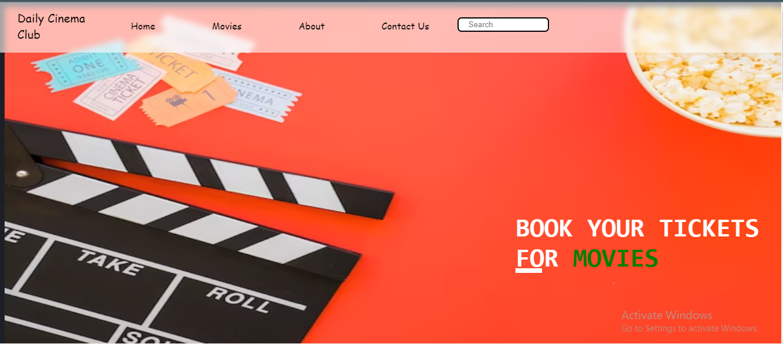

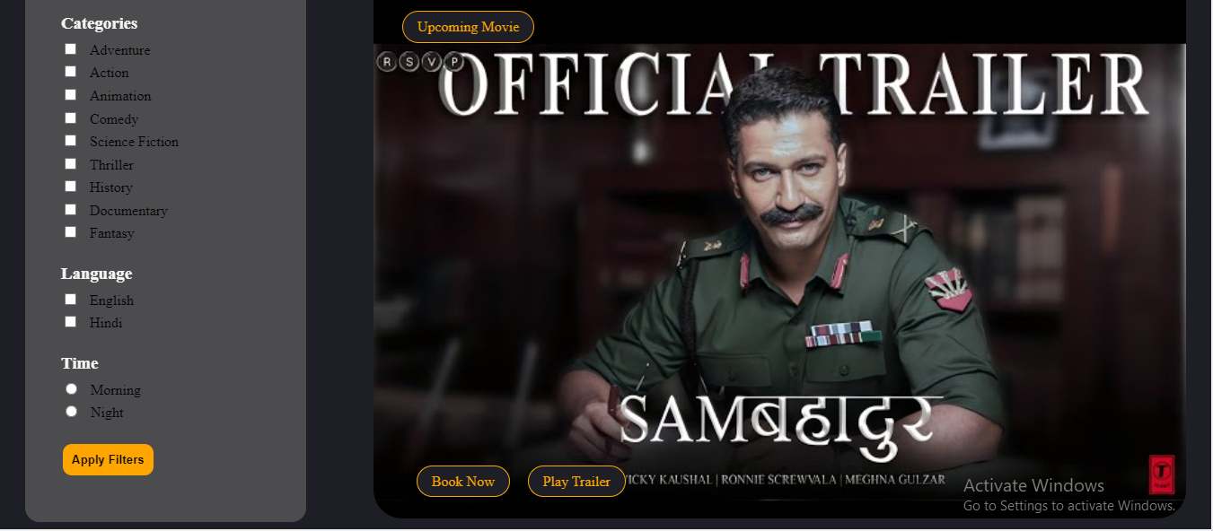

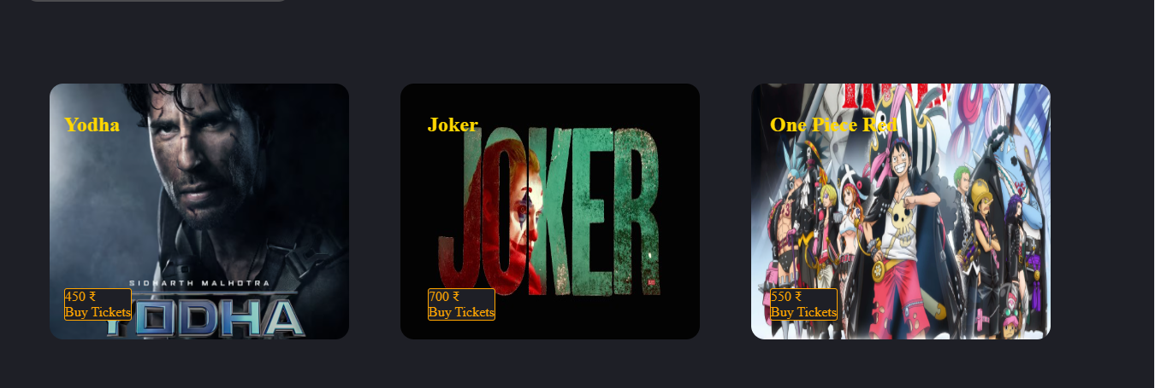

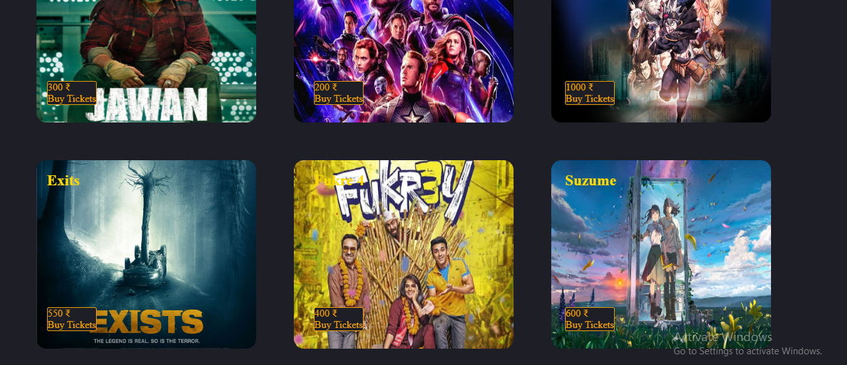

The home page consists navigation bar with attribute Home, Movies, about and Contact. In the navigation bar there is a search button for searching of movies. When you enter the website, user greeted with a stunning homepage. We ‘have made a filter section you can easily sort movies by genre! Like comedy, horror, action, animation and many more categories. On the left side of the filter section there is an upcoming movie poster with two button one is Buy Tickets and another one is Play Trailer button. When you click on the play trailer button then the trailer open in you tube.

Under the upcoming movie poster you will get the suggestions of different types of movie like horror, animation, documentary, fantasy and many more categories with their price tags and buy tickets enclose in a button and name of that movie. We also add images of all the movie.

In the absence of backend complexity, none of the button, checkbox and search bar works.

Cascading Style Sheets, plays a crucial role in web design by defining the visual presentation of a website. By using CSS we make the web pages look good by styling by adding many things like font-size, font-style, colour, layouts, background-colour and designs.

**About Page**

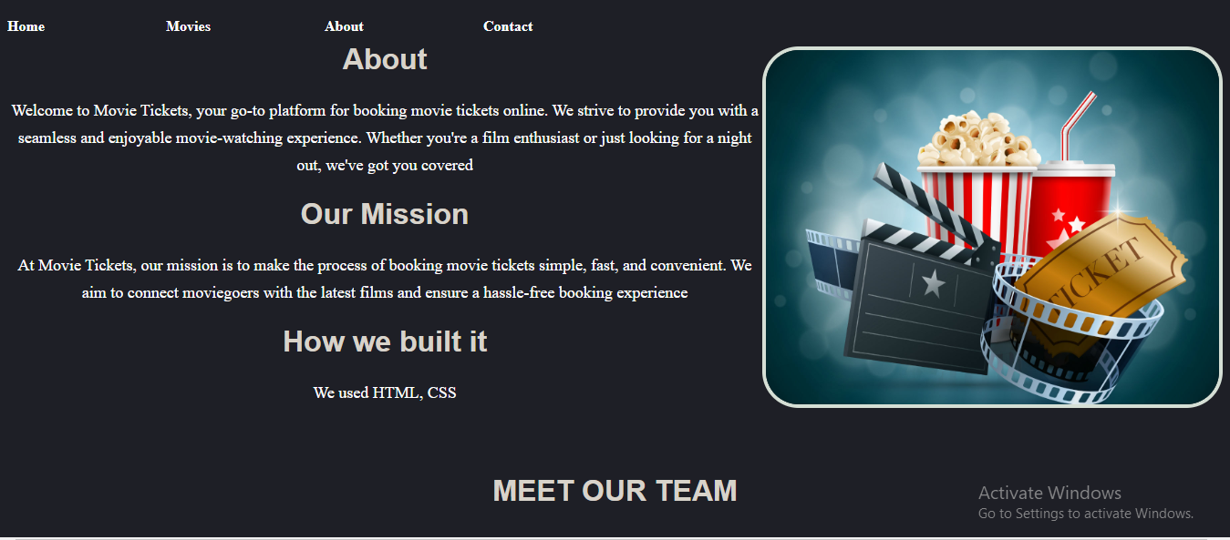

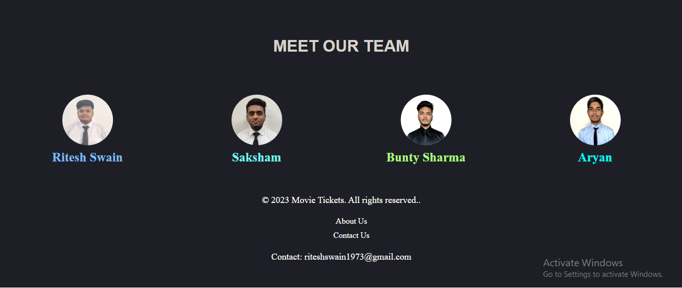

The about page also consists navigation bar with attribute Home, Movies, about and Contact.

We add an image that represent the movie booking website. Then there is written something about the website and our mission for making the website. We also write about what technology we used to make the website like HTML and CSS.

Then there is information about our team members with their picture and their name.

**Contact Page**

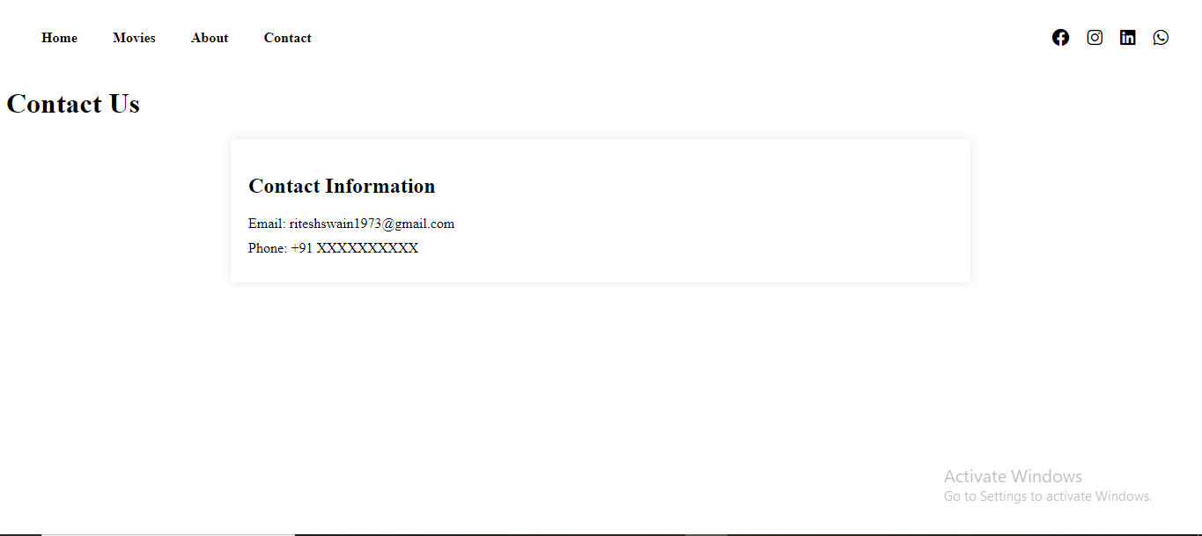

The contact page consists navigation bar with attribute Home, Movies, about and Contact.

We also add social media icon like Instagram, Facebook, LinkedIn and Whatsapp with social media link of team members in the navigation bar.

Then there is our email for users to contact with us.